**The data description of perceptual matching task**

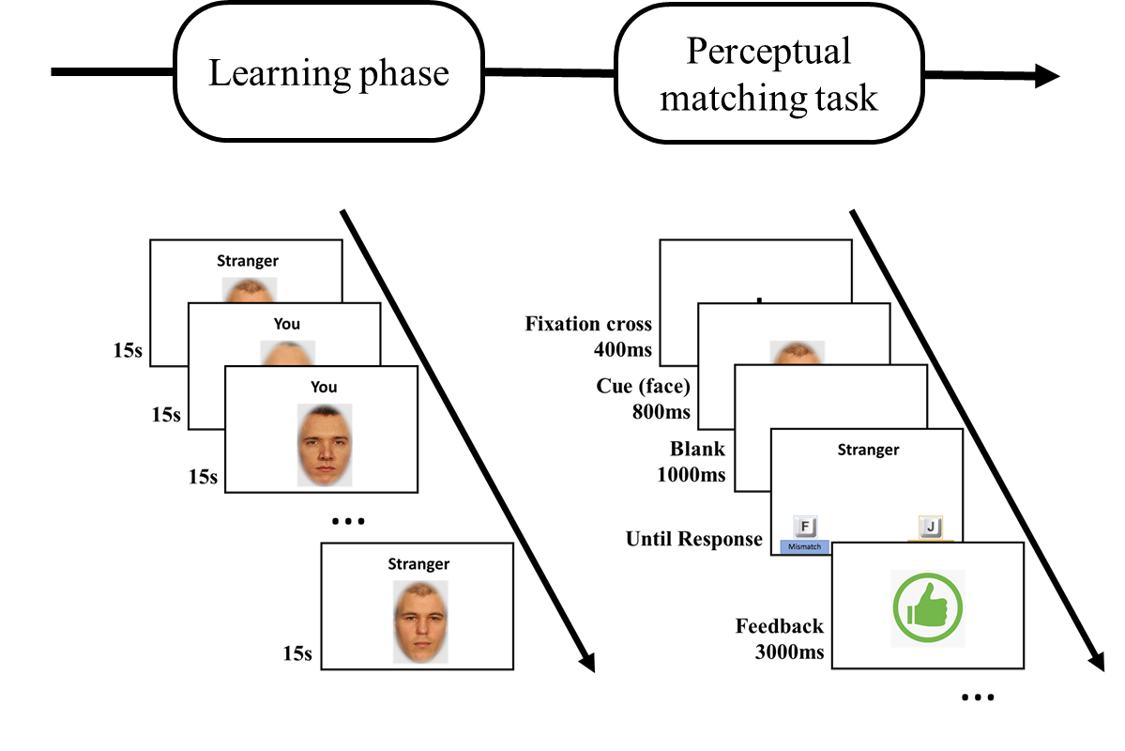

|  |  |  |
| --- | --- | --- |
| Variable Name | Description | Possible Value |
| Participant.Public.ID | The ID of participant | For example “612ca983e3b41811470cefae“ |
| Trial.Number | The trial number of each participant in this task | From 1 to 64 |
| Reaction.Time | Reaction time of one trial | ms |
| Response | Using the left button or the right button to response | “left” or “right” |
| Correct | If this response is correct in this trail | 1 - yes, 0 - No |
| Incorrect | If this response is wrong in this trail | 1 - yes, 0 - No |
| Label | Which label of face is showed in this trail. | “Me” or “Stranger” |
| Model | Which face model was showed in this trail. | Female model: “f15” “f18” “f27” “f4” Male model: “m33” “m34” “m35” “m38” |
| P_Group | Is this face model belonging to the self-related face or other-related face? (Please note that this categorization may vary for each participant due to randomization.) | "User" or “Other” |
| P_Orginal | Is the face photo in this trail (from same face model) used in the learning phase or not? | Yes - “JA”, No - “Nein” |
| ACC_Mat | The accuracy of this participant in this task | From 0 to 1 |